**THE INTERNATIONAL INSTITUTE OF INFORMATION TECHNOLOGY – HYDERABAD**

**Report on deep learning**

**Name:** Pranali Sharma

**Roll No:** UGMR20230042

**Fundamentals of Deep Learning**

**Introduction:** Deep Learning stands as a cornerstone technology, revolutionizing how machines understand, learn, and interact with complex data. At its essence, Deep Learning AI mimics the intricate neural networks of the human brain, enabling computers to autonomously discover patterns and make decisions from vast amounts of unstructured data.

**What is Deep Learning?**

The definition of Deep learning is that it is the branch of machine learning that is based on artificial neural network architecture. An artificial neural network or ANN uses layers of interconnected nodes called neurons that work together to process and learn from the input data.

This use multiple layers to progressively extract higher-level features from the raw input. It is particularly effective in handling large amounts of data and complex tasks like image and speech recognition, natural language processing, and autonomous driving.

**Basic Structure**

A neural network consists of layers of interconnected nodes, or neurons. Each neuron processes input data and passes its output to the next layer. The three main types of layers are:

* **Input Layer:** The layer that receives the initial data.
* **Hidden Layers:** Intermediate layers that process inputs from the previous layer.
* **Output Layer:** The layer that produces the final output.

Deep learning AI can be used for supervised, unsupervised as well as reinforcement machine learning. it uses a variety of ways to process these.

* **Supervised Machine Learning:** Supervised learning is a type of machine learning algorithm that learns from labelled data. Labelled data is data that has been tagged with a correct answer or classification.

Supervised learning, as the name indicates, has the presence of a supervisor as a teacher. Supervised learning is when we teach or train the machine using data that is well-labelled. Which means some data is already tagged with the correct answer. After that, the machine is provided with a new set of examples(data) so that the supervised learning algorithm analyses the training data (set of training examples) and produces a correct outcome from labelled data.

**Applications of Supervised learning**

* **Spam filtering:** Supervised learning algorithms can be trained to identify and classify spam emails based on their content, helping users avoid unwanted messages.
* **Image classification:** Supervised learning can automatically classify images into different categories, such as animals, objects, or scenes, facilitating tasks like image search, content 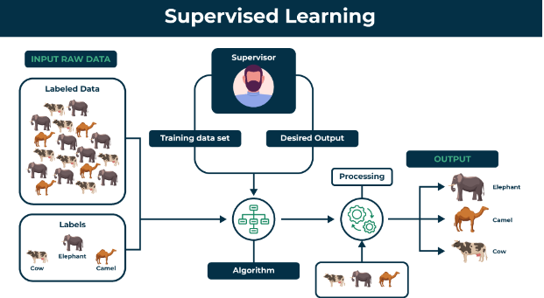moderation, and image-based product recommendations.

**Types of Supervised Learning**

1. **Regression**

Regression is a type of supervised learning that is used to predict continuous values, such as house prices, stock prices, or customer churn. Regression algorithms learn a function that maps from the input features to the output value.Some common regression algorithms include:

1. Linear Regression
2. Polynomial Regression
3. Support Vector Machine Regression
4. Decision Tree Regression
5. Random Forest Regression
6. **Classification**

Classification is a type of supervised learning that is used to predict categorical values, such as whether a customer will churn or not, whether an email is spam or not, or whether a medical image shows a tumor or not. Classification algorithms learn a function that maps from the input features to a probability distribution over the output classes.Some common classification algorithms include:

1. Logistic Regression
2. Support Vector Machines
3. Decision Trees
4. Random Forests

* 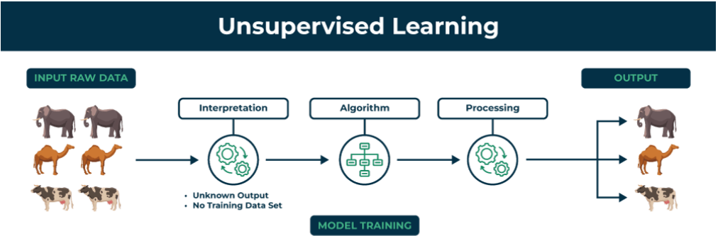**Unsupervised Machine Learning:** Unsupervised machine learning is the machine learning technique in which the neural network learns to discover the patterns or to cluster the dataset based on unlabelled datasets. Here there are no target variables. while the machine must self-determine the hidden patterns or relationships within the datasets. Deep learning algorithms like autoencoders and generative models are used for unsupervised tasks like clustering, dimensionality reduction, and anomaly detection.

**Application of Unsupervised learning:**

* **Anomaly detection:** Unsupervised learning can identify unusual patterns or deviations from normal behaviour in data, enabling the detection of fraud, intrusion, or system failures.
* **Scientific discovery:** Unsupervised learning can uncover hidden relationships and patterns in scientific data, leading to new hypotheses and insights in various scientific fields.

**Types of Unsupervised Learning:**

* **Clustering**: A clustering problem is where you want to discover the inherent groupings in the data, such as grouping customers by purchasing behaviour.
* **Association**: An association rule learning problem is where you want to discover rules that describe large portions of your data, such as people that buy X also tend to buy Y.
* **Reinforcement Machine Learning:** Reinforcement Machine Learning is a branch of machine learning that focuses on training computers to make optimal decisions by interacting with their environment. Instead of being given explicit instructions, the computer learns through trial and error: by exploring the environment and receiving rewards or punishments for its actions.

Together with supervised and unsupervised learning, reinforcement learning is one of three basic machine learning approaches. Reinforcement learning has a wide range of real-world applications, including robotics, game playing, and diagnosing rare diseases.

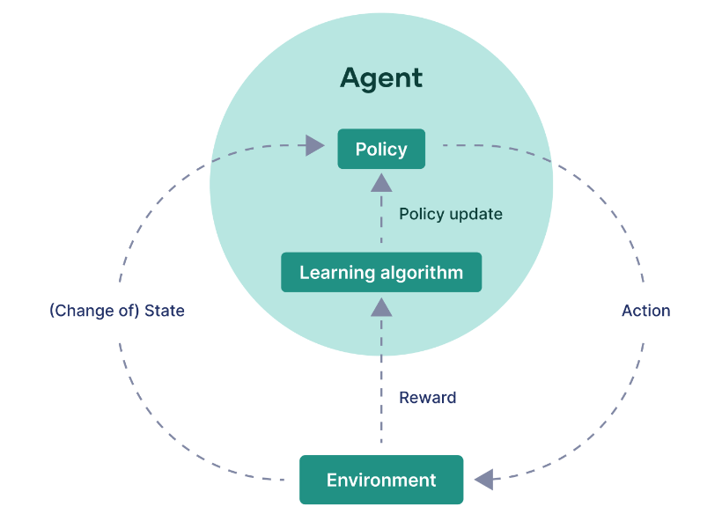

**Application of Reinforcement Learnings**:

* **Robotics:** Robots with pre-programmed behavior are useful in structured environments, such as the assembly line of an automobile manufacturing plant, where the task is repetitive in nature.

**Types of Reinforcement:**

There are two types of Reinforcement:

1. **Positive:**Positive Reinforcement is defined as when an event, occurs due to a particular behaviour, increases the strength and the frequency of the behaviour. In other words, it has a positive effect on behaviour.
2. **Negative:**Negative Reinforcement is defined as strengthening of behavior because a negative condition is stopped or avoided.   
   Advantages of reinforcement learning:

**Types of deep learning models:**

* Convolutional Neural Networks (CNNs)
* Recurrent Neural Networks (RNNs)

**Convolutional Neural Networks (CNNs)**

Convolutional Neural Networks (CNNs) are a type of deep learning model that anaylze visual data, such as images and videos.

**Purpose of CNNs:** CNNs are used for tasks like image recognition, object detection, and video analysis. They are well-suited for these tasks because they can learn to identify patterns in images and videos directly from the data.

**Working of Convolutional Neural Networks:**

**1. Convolutional Layers:** The convolutional layers are the core building blocks of a CNN. They apply a set of learnable filters (or kernels) to the input image, where each filter extracts a specific feature like edges, shapes, or textures. It performs dot product between the filter weights and input making an activation map .

**2. Activation Function:** A rectified linear activation function (ReLU) is applied after each convolution operation. ReLU introduces non-linearity, allowing the network to learn complex patterns in the data.

**3. Pooling Layers:** Pooling layers follow the convolutional layers and perform a down-sampling operation. They reduce the spatial dimensions of the feature maps, making the representations more compact and robust to small translations.

**4. Fully Connected Layers:** The final layers of a CNN are typically fully connected layers.

These layers take the high-level features extracted by the convolutional and pooling layers and use them to perform classification or regression tasks.

**5. Training:** CNNs are trained using backpropagation to minimize a loss function. The model learns to extract relevant features from the input data and associate them with the correct output labels.

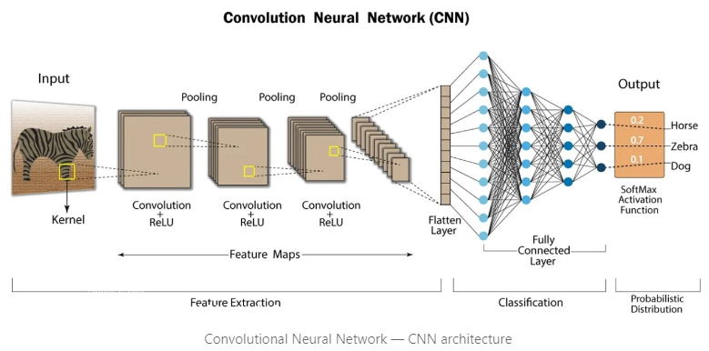

**Advantages of Convolutional Neural Networks (CNNs):**

1. CNNs can automatically learn and extract relevant features from the input data, without the need for manual feature engineering.

2. CNNs are highly scalable and can process large amounts of data quickly .

**Disadvantages of Convolutional Neural Networks (CNNs):**

1.Computationally expensive to train and require a lot of memory.

2.Requires large amounts of labelled data.

**Application of Convolutional Neural Networks (CNNs):**

* Image Classification: Assigning a label to an image.
* Object Detection: Identifying and localizing objects within an

image.

**Recurrent Neural Network (RNN)**

Recurrent Neural Network(RNN) is a type of Neural Network where the output from the previous step is fed as input to the current step. In traditional neural networks, all the inputs and outputs are independent of each other. Still, in cases when it is required to predict the next word of a sentence, the previous words are required and hence there is a need to remember the previous words.

The main and most important feature of RNN is its **Hidden state**, which remembers some information about a sequence. The state is also referred to as Memory Statesince it remembers the previous input to the network.

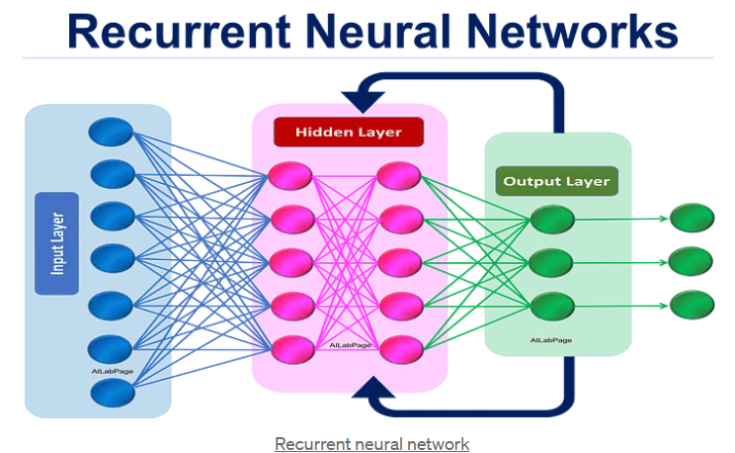

**How does RNN work?**

The Recurrent Neural Network consists of multiple fixed activation function units, one for each time step. Each unit has an internal state which is called the hidden state of the unit. This hidden state signifies the past knowledge that the network currently holds at a given time step. This hidden state is updated at every time step to signify the change in the knowledge of the network about the past. The hidden state is updated using the following recurrence relation:-

**The formula for calculating the current state:**

ℎ𝑡=𝑓(ℎ𝑡−1,𝑥𝑡)*ht*​=*f*(*ht*−1​,*xt*​)

where,

* ht -> current state
* ht-1 -> previous state
* xt -> input state

**Formula for applying Activation function(tanh)**

ℎ𝑡=𝑡𝑎𝑛ℎ(𝑊ℎℎℎ𝑡−1+𝑊𝑥ℎ𝑥𝑡)*ht*​=*tanh*(*Whh*​*ht*−1​+*Wxh*​*xt*​)

where,

* whh -> weight at recurrent neuron
* wxh -> weight at input neuron

**The formula for calculating output:**

𝑦𝑡=𝑊ℎ𝑦ℎ𝑡*yt*​=*Why*​*ht*​

* Yt -> output
* Why -> weight at output layer

These parameters are updated using Backpropagation. However, since RNN works on sequential data here we use an updated backpropagation which is known as Backpropagation through time.

**Backpropagation through time:** Backpropagation is done at each point in time. At timestep 𝑇*T*, the derivative of the loss 𝐿L with respect to weight matrix 𝑊*W* is expressed as follows:

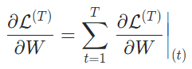

**Advantages of Recurrent Neural Network(RNN) :**

1. An RNN remembers each and every piece of information through time. It is useful in time series prediction only because of the feature to remember previous inputs as well. This is called Long Short Term Memory.
2. Recurrent neural networks are even used with convolutional layers to extend the effective pixel neighbourhood.

**Disadvantages of Recurrent Neural Network(RNN) :**

1. Gradient vanishing and exploding problems.
2. Training an RNN is a very difficult task.

**Applications of Recurrent Neural Network(RNN) :**

* Time Series Prediction: Any time series problem, like predicting the prices of stocks in a particular month, can be solved using an RNN.
* Natural Language Processing: Text mining and Sentiment analysis can be carried out using an RNN for Natural Language Processing (NLP).

**Transformers**

Transformers are a type of deep learning architecture that has revolutionized natural language processing (NLP) and has been increasingly applied to other areas such as computer vision, speech recognition, and more.

Transformer Architecture is a model that uses self-attention that transforms one whole sentence into a single sentence. This is a big shift from how older models work step by step, and it helps overcome the challenges seen in models like RNNs.

**How transformer models are different**

The key innovation of the transformer model is not having to rely on recurrent neural networks (RNNs) or convolutional neural networks (CNNs), neural network approaches which have significant drawbacks. Transformers process input sequences in parallel, making it highly efficient for training and inference — because you can’t just speed things up by adding more GPUs. Transformer models need less training time than previous recurrent neural network architectures such as long short-term memory (LSTM).

RNNs and LSTM date back to the 1920s and 1990s, respectively. These techniques compute each component of an input in sequence (e.g. word by word), so computation can take a long time. What’s more, both approaches run into limitations in retaining context when the “distance” between pieces of information in an input is long.

**Architecture and Working of Transformers:**

1. Input Embedding: Converts input tokens (words, subwords, etc.) into dense vectors.
2. Positional Encoding: Adds positional information to the input embeddings.
3. Encoder Layers:

* Multi-Head Self-Attention: Allows the model to focus on different parts of the input sequence.
* Feed-Forward Neural Network: Applies a fully connected neural network to the outputs of the attention mechanism.
* Layer Normalization and Residual Connections: Helps with training stability and gradient flow.

1. Decoder Layers: Like encoder layers but include additional mechanisms to handle the generation of sequences.

* Masked Multi-Head Self-Attention: Ensures the model does not look ahead in the sequence during training.
* Encoder-Decoder Attention: Allows the decoder to focus on relevant parts of the input sequence.

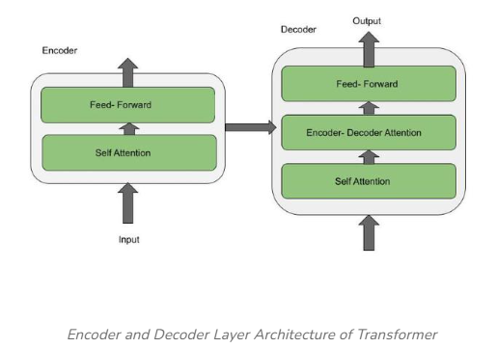Ex: There is a word -’ **Point**’, and we use it in two different contexts given below

* The needle has a sharp**point**.
* It is not polite to**point** at people.

Here, the word **‘Point’** has two different contexts in both of the sentences, but when embedding is done the context is not taken into consideration. Therefore, there was a need for a different architecture Transformer.

**Advantages of Transformers:**

* **Scalability**: Transformers can scale up with more data and computational resources
* **Versatility**: Applicable to a wide range of tasks and domains.

**Disadvantages of Transformers:**

* **Computationally Intensive**: Requires significant computational resources, especially for training large models.
* **Data-Hungry**: Needs large datasets for effective training.

**Applications of Transformer:**

* Transformers is used for NLP tasks like, machine translation, text summarization, name entity recognition and sentimental analysis.
* Another application is speech recognition system, where audio signals are processed to provide transcribed text.

**Conclusion:** Deep Learning has revolutionized various fields by enabling the development of models that can learn complex patterns from large datasets. Understanding the fundamentals of neural networks, CNNs, RNNs, and transformers provides a strong foundation for exploring advanced deep learning techniques and applications.

**GITHUB LINK:** https://github.com/Pranali-25/Capstone-Project